**BSc (hons) Software Engineering**

**BSSE0122011374**

**M.P. Pawan**

**Software Quality Assurance**

01). “House of Curtains” Website

One drive link- <https://saegis-my.sharepoint.com/:u:/g/personal/bsse0122011374_saegis_ac_lk/EUnoop5ODPpKhYmdgN1jT_kBnNX6f9gZMOoF-4X0-MMx3w?e=TsfLvZ>

02).

|  |  |  |  |  |  |  |  |
| --- | --- | --- | --- | --- | --- | --- | --- |
| **Test ID** | **Title** | **Precondition** | **Test Steps** | **Expected Result** | **Actual Result** | **Status (Pass/Fail)** | **Priority** |
| Test01 | Insert customer details | Go to customer details page | Enter Name  Enter Contact no  Enter Address  Select Date  Submit | Display the “Customer details and New records created”. | Display the “Customer details and New records created”. | Pass | High |
| Test01 | Enter the material code | Go to Store page | Input code  Input the length needed  search | Display the “Material name,  Number of rolls remaining,  Meter amount in using roll”. | Display the “Material name,  Number of rolls remaining,  Meter amount in using roll”. | Pass | High |
| Test03 | Select “Using current roll”. | Go to Using current roll | Input Foot  Input Material code  Search | Display “Connection confirmed and New record created”. | Display “Connection confirmed and New record created”. | Pass | Medium |
| Test04 | Select “Switch to a new roll”. | Switch to a new roll | Select “Yes”.  Input Foot  Input Material code  Search | Update the database. | Result is shown as Expected. | Pass | High |
| Test05 | Create the bar email receipt. | Go to the Accessories page and after Required bars | Enter the receipt no  Click Required bars button  Enter Receipt No  Choose item name  Required amount of bars  Add item  Generate Receipt | Display the receipt. | Result is shown as Expected. | Pass | High |
| Test06 | Submit the types and amount | Go to the Accessories | Select Iylet type and amount  Select Bracket type and amount  Select End-cup type and amount | Update the database. | Result is shown as Expected. | Pass | High |
| Test07 | Print Receipt | Go to Print Receipt page | Add Receipt No  Add Customer Name  Add Customer Contact  Add Item name  Add item price  Discount  Print Receipt | Display the receipt | Display the receipt | Pass | High |
| Test08 | Update Order Status | Go to Order Tracking | Select receipt number  Go update order status  Add receipt number  Select order status  And Update | Update Database | Result is shown as Expected. | Pass | Fail |
| Test09 | Check the order Status | Go to Order Tracking | Enter Receipt Number  Enter | Display the order status | Error messages are displayed | Fail | Medium |
| Test10 | Check the Customer Receipts | Go to Customer details | Click Customer Receipts  Enter Customer contact  Search | Display the Receipt | Display “No data found in the table.” | Fail | High |

03)

Test1

|  |  |
| --- | --- |
| [SCRUM-1] [Check the Customer Receipts](https://mppawan99-1722500872551.atlassian.net/browse/SCRUM-1) **Created: 01/Aug/24  Updated: 01/Aug/24** | |
| **Status:** | In Progress |
| **Project:** | [House of Curtains](https://mppawan99-1722500872551.atlassian.net/secure/BrowseProject.jspa?id=10000) |
| **Components:** | None |
| **Affects versions:** | None |
| **Fix versions:** | None |

|  |  |  |  |
| --- | --- | --- | --- |
| **Type:** | Task | **Priority:** | Medium |
| **Reporter:** | [pasindu pawan](https://mppawan99-1722500872551.atlassian.net/secure/ViewProfile.jspa?accountId=712020%3Ac352f084-aa72-48de-9dbc-c55ed8ce4ce7) | **Assignee:** | [pasindu pawan](https://mppawan99-1722500872551.atlassian.net/secure/ViewProfile.jspa?accountId=712020%3Ac352f084-aa72-48de-9dbc-c55ed8ce4ce7) |
| **Resolution:** | Unresolved | **Votes:** | 0 |
| **Labels:** | None | | |
| **Remaining Estimate:** | Not Specified | | |
| **Time Spent:** | Not Specified | | |
| **Original estimate:** | Not Specified | | |

|  |  |
| --- | --- |
| **Rank:** | 0|hzzzzz: |
| **Sprint:** |  |
| **Story point estimate:** | -2 |

|  |  |
| --- | --- |
| **Description** |  |

|  |
| --- |
| Admin can see the customer receipts enter the customer contact number. |

Generated at Thu Aug 01 17:39:14 UTC 2024 by pasindu pawan using Jira 1001.0.0-SNAPSHOT#100261-rev:763923dae9fba217e713c34e60275af0ad457e9a.

Bug1

|  |  |
| --- | --- |
| [SCRUM-2] [Display “No data found in the table.”](https://mppawan99-1722500872551.atlassian.net/browse/SCRUM-2) **Created: 01/Aug/24  Updated: 01/Aug/24** | |
| **Status:** | In Progress |
| **Project:** | [House of Curtains](https://mppawan99-1722500872551.atlassian.net/secure/BrowseProject.jspa?id=10000) |
| **Components:** | None |
| **Affects versions:** | None |
| **Fix versions:** | None |

|  |  |  |  |
| --- | --- | --- | --- |
| **Type:** | Bug | **Priority:** | Medium |
| **Reporter:** | [pasindu pawan](https://mppawan99-1722500872551.atlassian.net/secure/ViewProfile.jspa?accountId=712020%3Ac352f084-aa72-48de-9dbc-c55ed8ce4ce7) | **Assignee:** | [pasindu pawan](https://mppawan99-1722500872551.atlassian.net/secure/ViewProfile.jspa?accountId=712020%3Ac352f084-aa72-48de-9dbc-c55ed8ce4ce7) |
| **Resolution:** | Unresolved | **Votes:** | 0 |
| **Labels:** | None | | |
| **Remaining Estimate:** | Not Specified | | |
| **Time Spent:** | Not Specified | | |
| **Original estimate:** | Not Specified | | |

|  |  |
| --- | --- |
| **Rank:** | 0|i00007: |
| **Sprint:** |  |

|  |  |
| --- | --- |
| **Description** |  |

|  |
| --- |
| When user enter the customer contact number after display the customer receipts but this is not display the receipts and display the “No data found in the table”.  **Steps** **:**   * Click Customer Receipts * Enter Customer contact * Search   Expected result: Display the Receipt  Actual result: Display the “No data found in the table”.  Status : Test10 is Fail. |

Generated at Thu Aug 01 17:39:24 UTC 2024 by pasindu pawan using Jira 1001.0.0-SNAPSHOT#100261-rev:763923dae9fba217e713c34e60275af0ad457e9a.

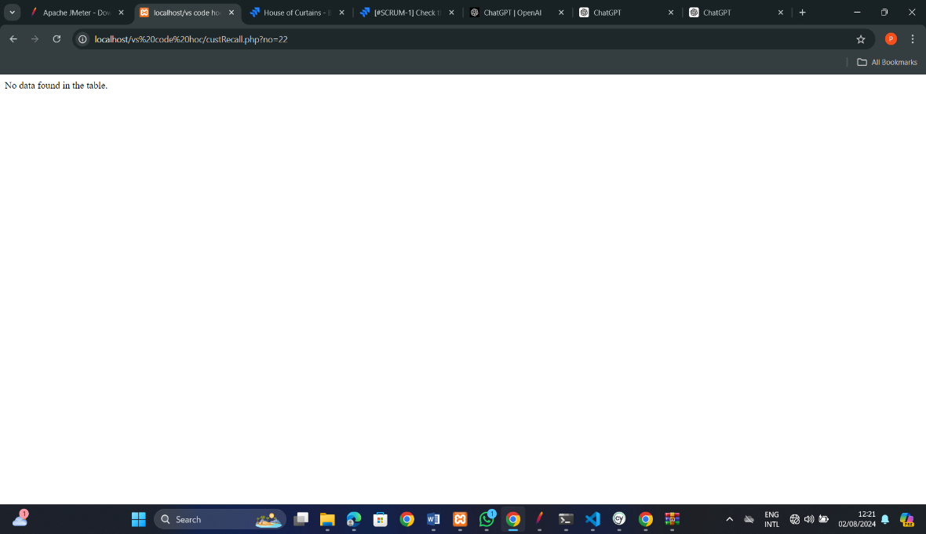

Test2

|  |  |
| --- | --- |
| [SCRUM-3] [Check the order Status](https://mppawan99-1722500872551.atlassian.net/browse/SCRUM-3) **Created: 01/Aug/24  Updated: 01/Aug/24** | |
| **Status:** | In Progress |
| **Project:** | [House of Curtains](https://mppawan99-1722500872551.atlassian.net/secure/BrowseProject.jspa?id=10000) |
| **Components:** | None |
| **Affects versions:** | None |
| **Fix versions:** | None |

|  |  |  |  |
| --- | --- | --- | --- |
| **Type:** | Task | **Priority:** | Medium |
| **Reporter:** | [pasindu pawan](https://mppawan99-1722500872551.atlassian.net/secure/ViewProfile.jspa?accountId=712020%3Ac352f084-aa72-48de-9dbc-c55ed8ce4ce7) | **Assignee:** | [pasindu pawan](https://mppawan99-1722500872551.atlassian.net/secure/ViewProfile.jspa?accountId=712020%3Ac352f084-aa72-48de-9dbc-c55ed8ce4ce7) |
| **Resolution:** | Unresolved | **Votes:** | 0 |
| **Labels:** | None | | |
| **Remaining Estimate:** | Not Specified | | |
| **Time Spent:** | Not Specified | | |
| **Original estimate:** | Not Specified | | |

|  |  |
| --- | --- |
| **Rank:** | 0|i0000f: |
| **Sprint:** |  |

|  |  |
| --- | --- |
| **Description** |  |

|  |
| --- |
| Input the order number after enter Display the order status. |

Generated at Thu Aug 01 17:50:25 UTC 2024 by pasindu pawan using Jira 1001.0.0-SNAPSHOT#100261-rev:763923dae9fba217e713c34e60275af0ad457e9a.

Bug2

|  |  |
| --- | --- |
| [SCRUM-4] [Check the order Status](https://mppawan99-1722500872551.atlassian.net/browse/SCRUM-4) **Created: 01/Aug/24  Updated: 01/Aug/24** | |
| **Status:** | In Progress |
| **Project:** | [House of Curtains](https://mppawan99-1722500872551.atlassian.net/secure/BrowseProject.jspa?id=10000) |
| **Components:** | None |
| **Affects versions:** | None |
| **Fix versions:** | None |

|  |  |  |  |
| --- | --- | --- | --- |
| **Type:** | Bug | **Priority:** | Medium |
| **Reporter:** | [pasindu pawan](https://mppawan99-1722500872551.atlassian.net/secure/ViewProfile.jspa?accountId=712020%3Ac352f084-aa72-48de-9dbc-c55ed8ce4ce7) | **Assignee:** | [pasindu pawan](https://mppawan99-1722500872551.atlassian.net/secure/ViewProfile.jspa?accountId=712020%3Ac352f084-aa72-48de-9dbc-c55ed8ce4ce7) |
| **Resolution:** | Unresolved | **Votes:** | 0 |
| **Labels:** | None | | |
| **Remaining Estimate:** | Not Specified | | |
| **Time Spent:** | Not Specified | | |
| **Original estimate:** | Not Specified | | |

|  |  |
| --- | --- |
| **Rank:** | 0|i0000n: |
| **Sprint:** |  |

|  |  |
| --- | --- |
| **Description** |  |

|  |
| --- |
| Input the receipt number after display Error messages are displayed. |

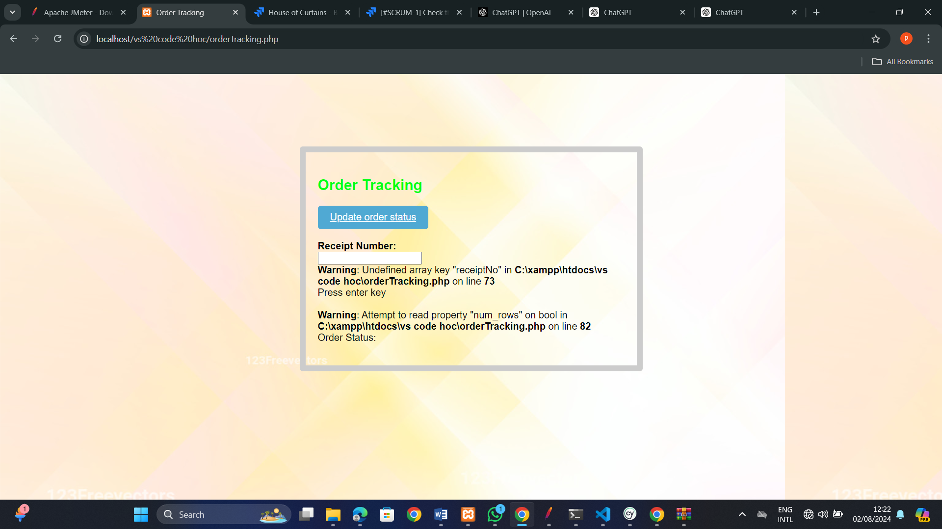Generated at Thu Aug 01 17:50:36 UTC 2024 by pasindu pawan using Jira 1001.0.0-SNAPSHOT#100261-rev:763923dae9fba217e713c34e60275af0ad457e9a.

04)

Customer details page automation test

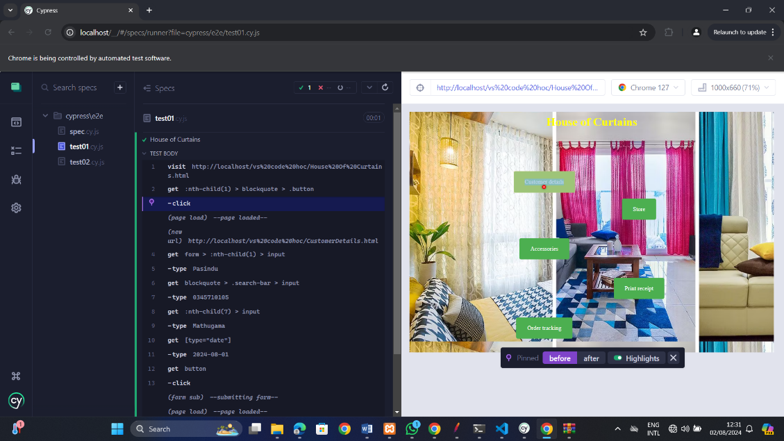

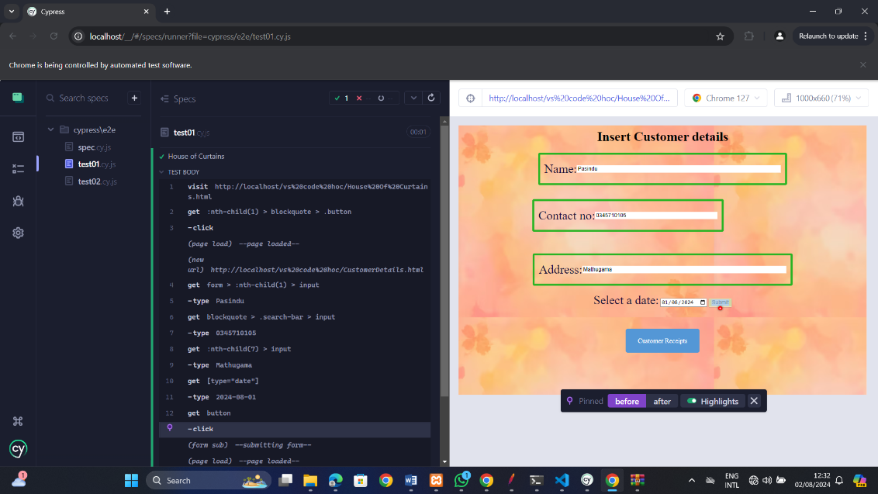

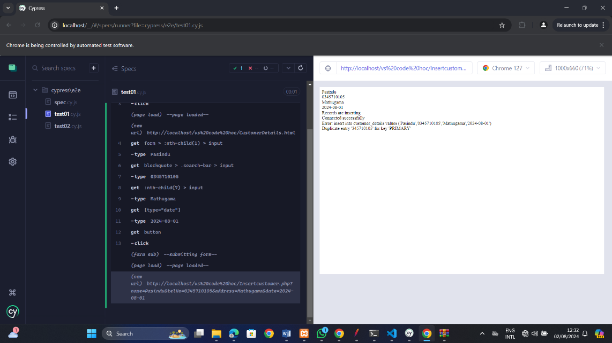

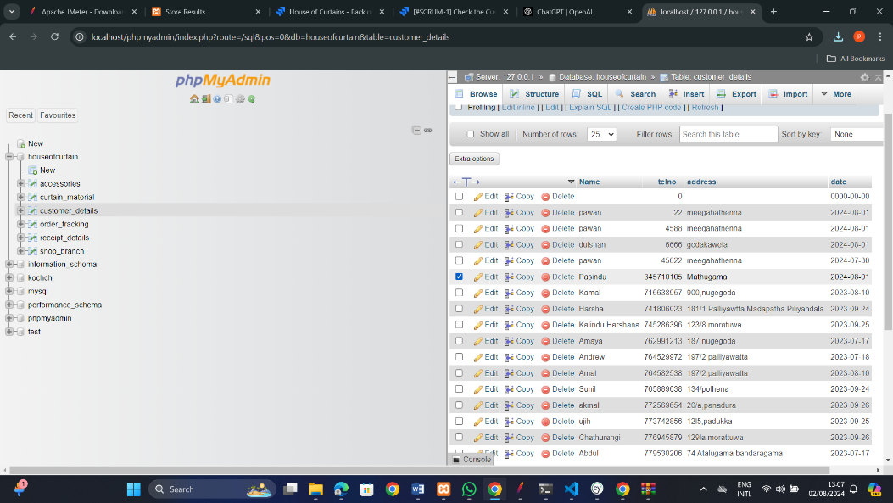Database result

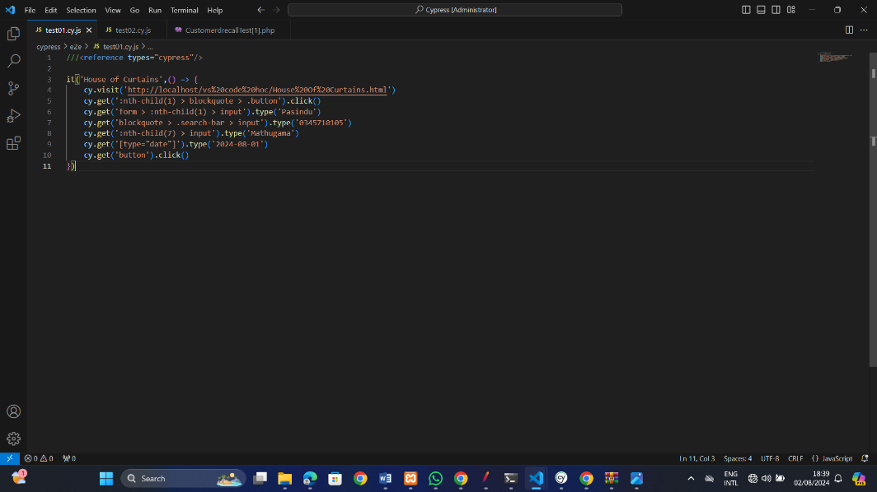Cypress test Automation code

Store page automation test

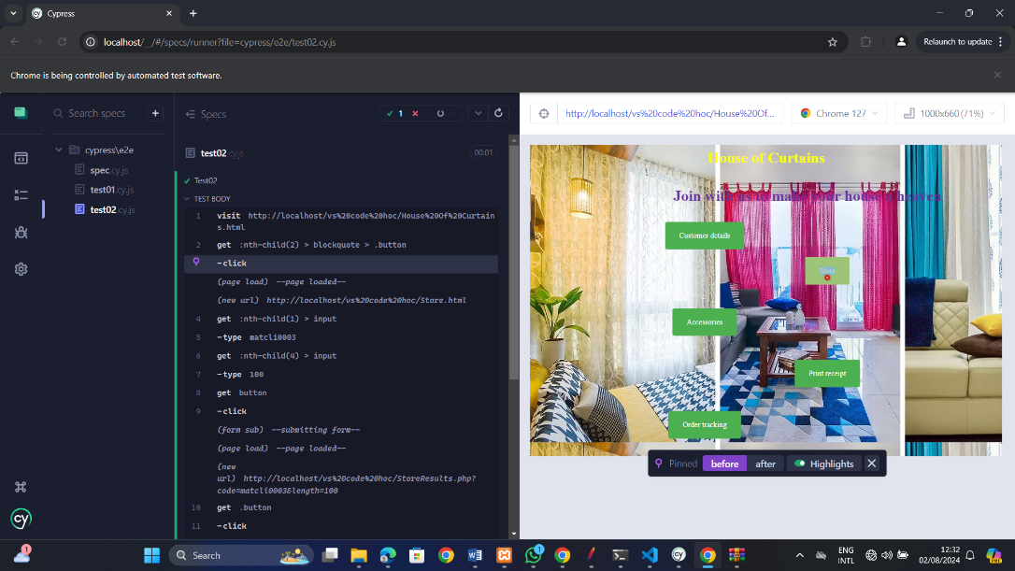

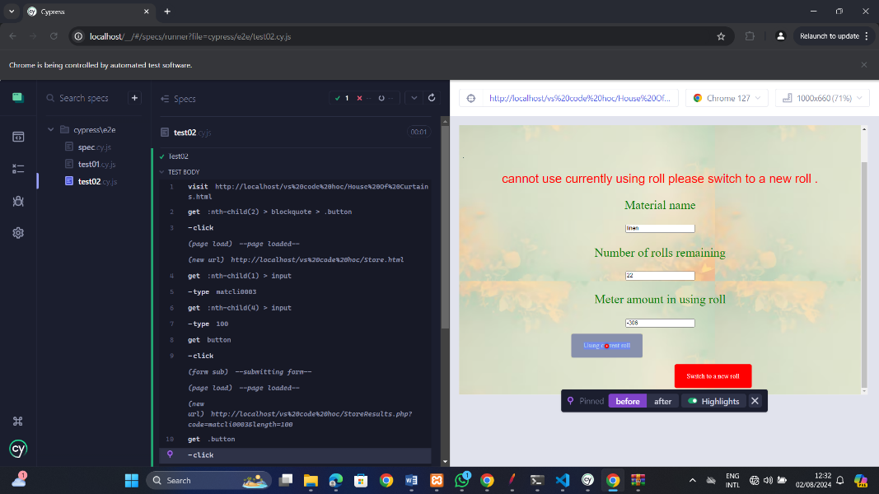

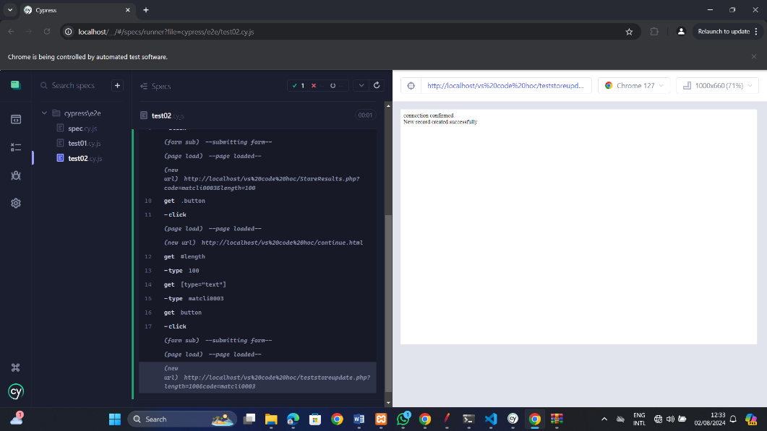

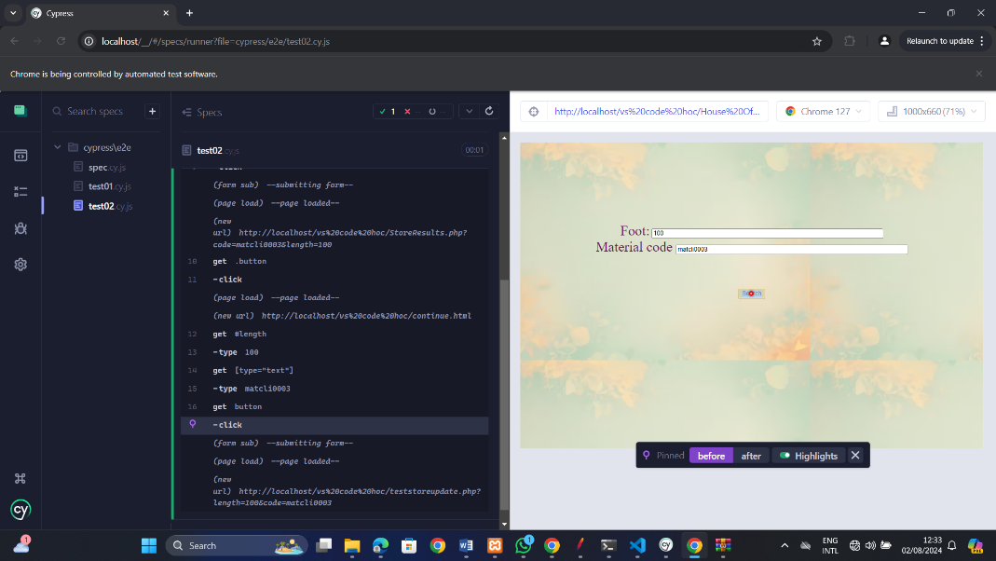

Database result

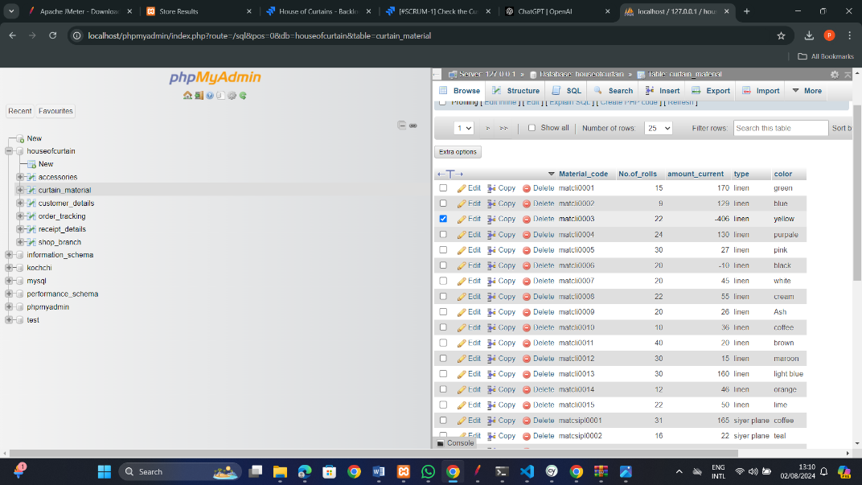

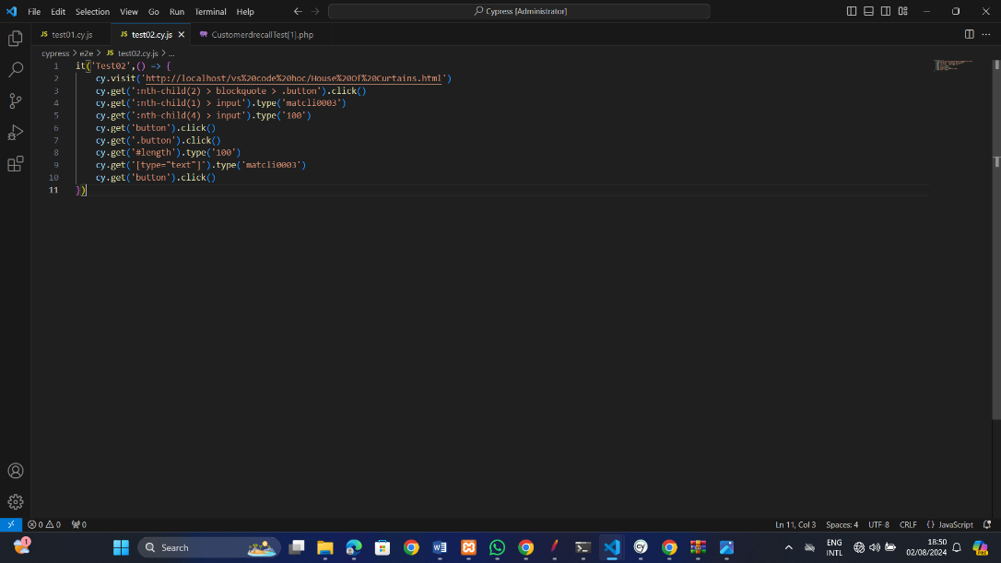Cypress test Automation code

**Unit test**

Customer details display code

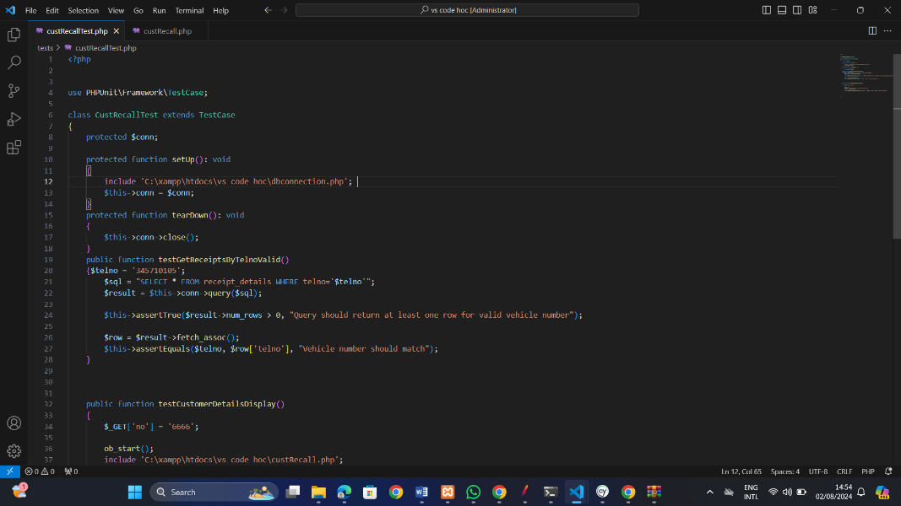

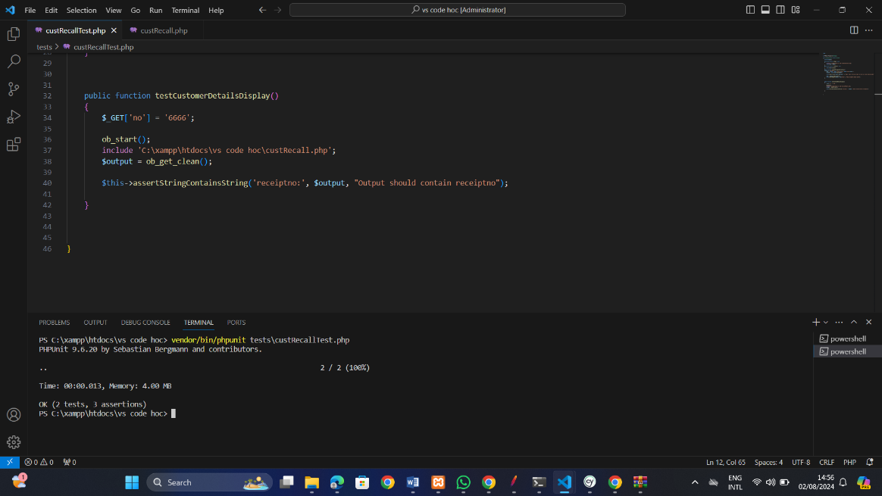

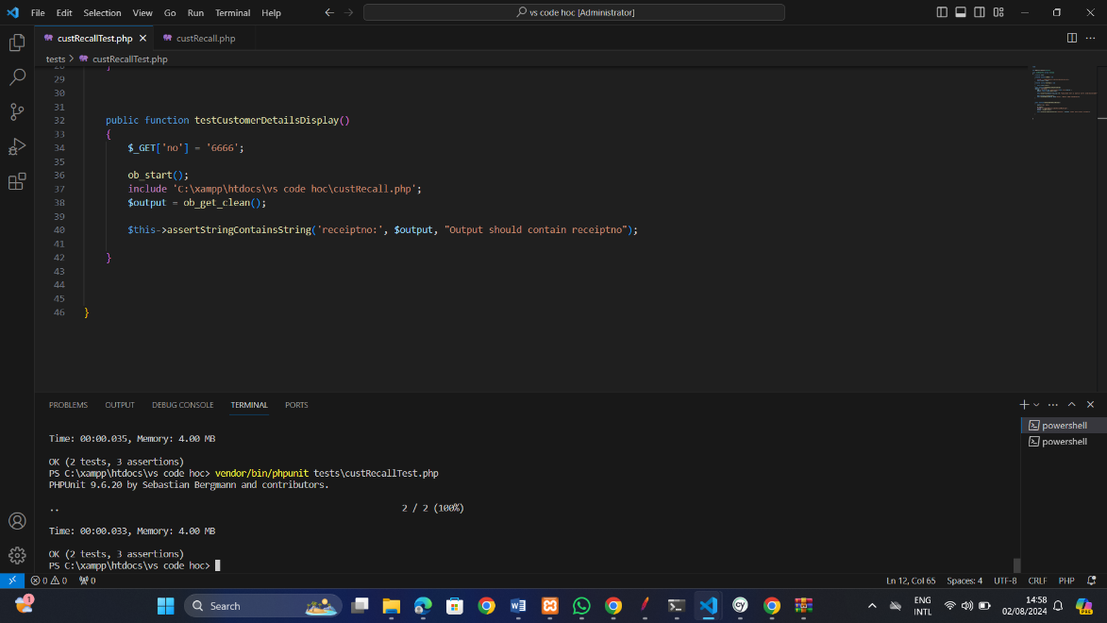Customer details retrieve code

05).

|  |  |
| --- | --- |
| **Test Scenario** | Customer Details |
| **Test Data** | Name – Pasindu Pawan  Contact No – 0345710105  Address – Mathugama  Date- 2024.08.02 |
| **Response Time** | 103ms |
| **Throughput** | 5.0/min |
| **Expected Result** | Response Time – < 2s  Throughput – 60/min  Error Rate – 0%  Latency – 100ms |
| **Actual Result** | Response Time – 103ms  Throughput – 5.0/min  Error Rate – 0.00%  Latency – 100ms |

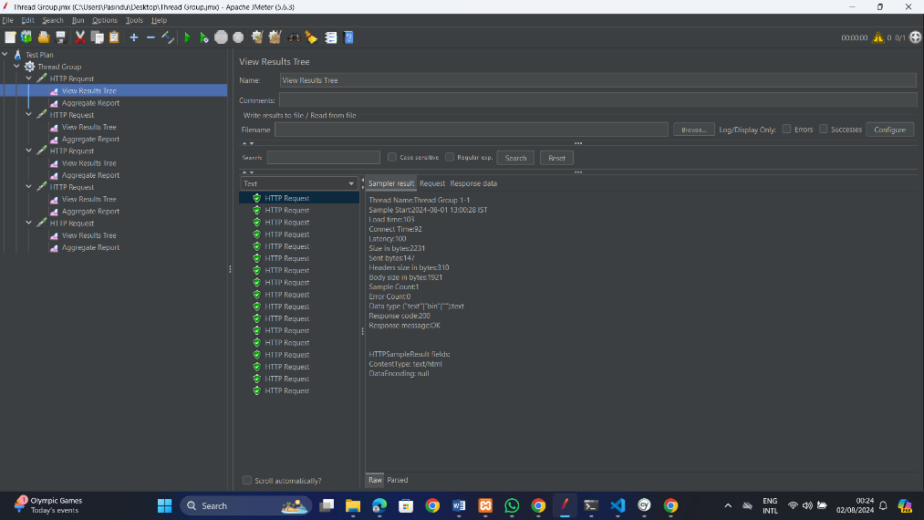

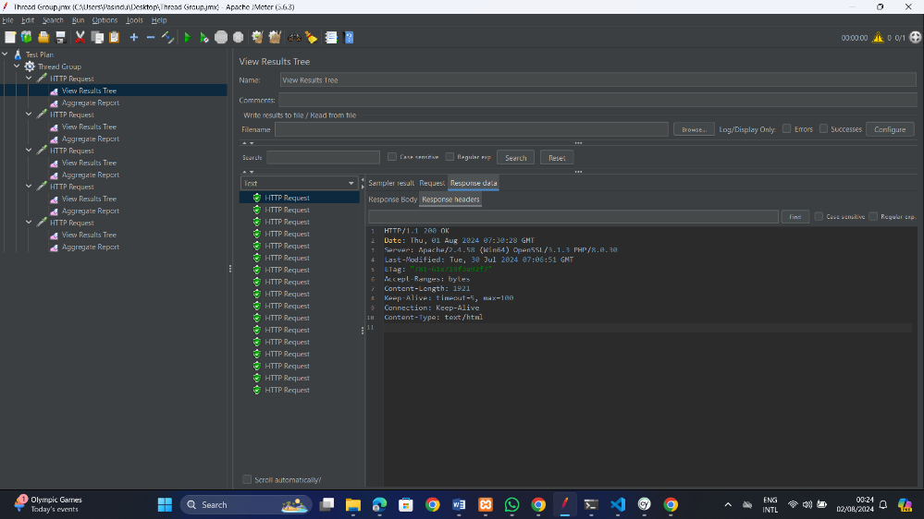

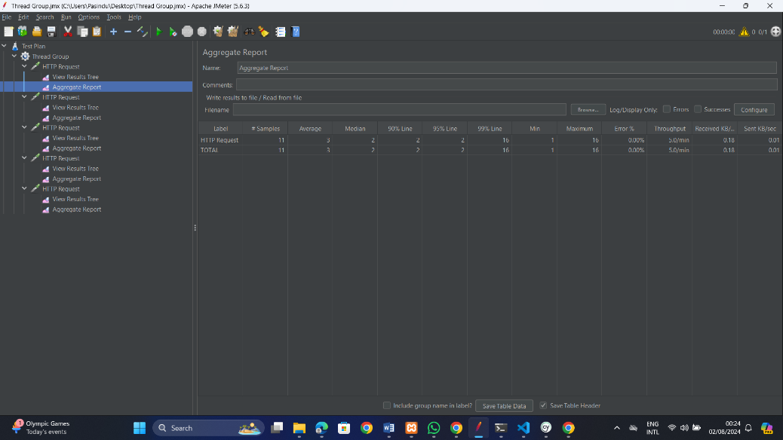

|  |  |
| --- | --- |
| **Test Scenario** | Store Details |
| **Test Data** | Material name- Linen  Number of roll remaining- 22  Meter amount in using roll- 308 |
| **Response Time** | 14ms |
| **Throughput** | 6.3/min |
| **Expected Result** | Response Time – < 2s  Throughput – 60/min  Error Rate – 0%  Latency – 50ms |
| **Actual Result** | Response Time – 14ms  Throughput – 6.3/min  Error Rate – 0.00%  Latency – 14ms |

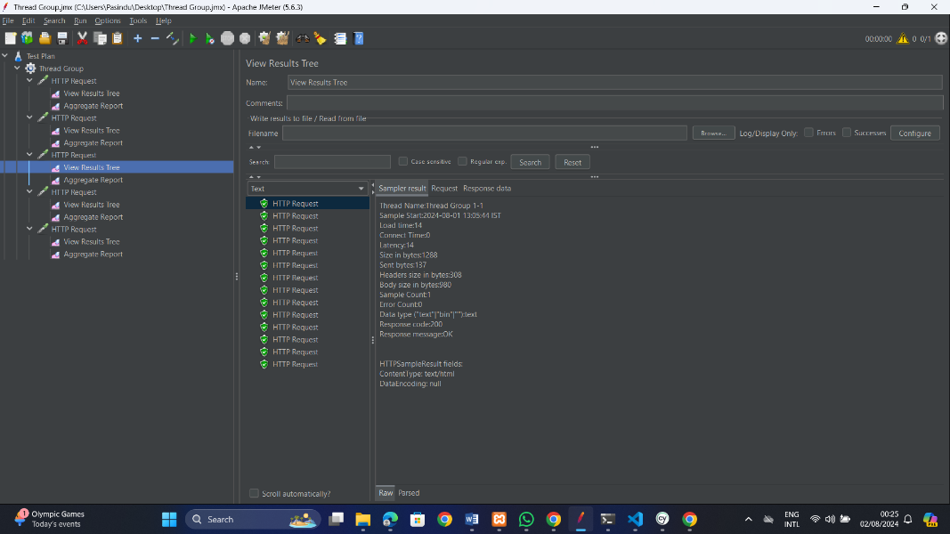

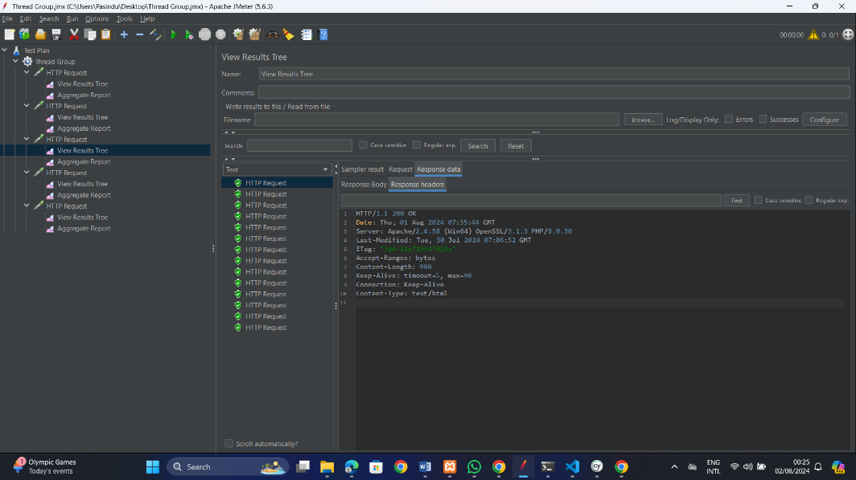

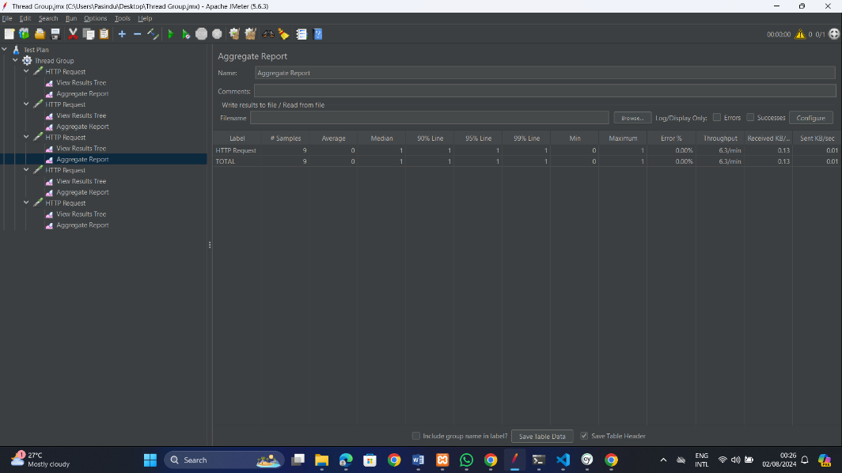

|  |  |
| --- | --- |
| **Test Scenario** | Accessories page |
| **Test Data** | Receipt No-2  Lylet type- Flower (2amount)  Bracket Type-Type1 (3amount)  Endcup Type-Type4(3amount) |
| **Response Time** | 1ms |
| **Throughput** | 5.7/min |
| **Expected Result** | Response Time – < 2s  Throughput – 60/min  Error Rate – 0%  Latency – 50ms |
| **Actual Result** | Response Time – 1ms  Throughput – 5.7/min  Error Rate – 0.00%  Latency – 0 |

